

**MOHD PARVEJ ALAM**

**Title:**

Associate II

–

Software

Engineer

**Location:**

Pratapgarh

,

Uttar Pradesh

,

India

**Languages**

**:**

Hindi (

conversational

)

,

English (fluent

)

Experience Summary

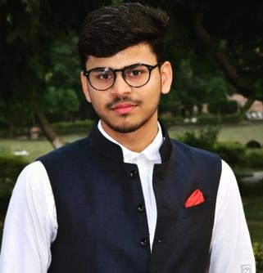

* Fresher with training in Full Stack Web development.
* Good understanding of Programming Language and Data Structures – C++
* Good understanding of MERN stacks and MEAN stack.
* Good understanding of ASP.Net Core MVC

*KEY SKILLS:*

▪ **Functional:** Team Leader, Excellent Communication and Interpretation skills

* **Technical:** JavaScript , MySQL, MongoDB, Nodejs ,React ,Angular, C++ ,C#/.NET,Core MVC

# Experience

|  |  |  |  |
| --- | --- | --- | --- |
| **01** | **Type of Industry: Project Description:**  **Role/Title:**  **Project Duration:**  **Responsibilities:**  **Operating Systems:**  **Software /**  **Languages:**  **Special Tools:** | **(Part of training at Capgemini under Accruent)** Employee Management System  A C#/.NET Full Stack WebProject  Personal Project  February 2023 – April, 2023   * Writing backend code with C#/.Net. * Use SQL Server to store the all records of Employee and Skills. * A Admin, who manage all the employee record like create a skill, assign a skill to employee. * Login Page for Admin and search and export functionality.   Windows  C#, .NET  Visual Studio Code,SqlServer |  |



|  |  |  |
| --- | --- | --- |
|  |  |  |
| **02** | **Type of Industry:** | **(Part of the L1 training at Capgemini for freshers)** |
|  | **Project**  **Description:** | Book My Courier Application  A MEAN and MERN STACK PROJECT |
|  | **Role/Title:** | Lead |
|  | **Project Duration:** | October, 2022 – November, 2022 |
|  | **Responsibilities:** | * Writing backend code with NodeJs and Express Framework * Writing code for home components of Book My Courier Applcation * Writing code for login and register as a customer |
|  | **Operating Systems:** | Windows 10 |
|  | **Software / Languages:** | NodeJS, MongoDB, Angular,React,ExpressJs |
|  | **Special Tools:** | Visual Studio Code, Postman, MongoDB Compass |

# Training, Certifications & Affiliations

* ASP .Net Core MVC Training under Accruent
* MEAN Stack Training from Capgemini Pvt. Ltd.
* MERN Stack Training from Capgemini Pvt. Ltd.

# Higher Education

• Dr B R Ambedkar National Institute of Technology, Jalandhar– Bachelor of Technology (Electronics and Communication Engineering)

Resume | <MOHD PARVEJ ALAM_46269473>| Copyright ©2016 Capgemini. All rights reserved. Page 2 /2